

## FILM PRODUCTION COMPANY DATABASE ANALYSIS & MANAGEMENT

Presented by: Tanmayi Patil

Course: Java Full Stack Development (SQL Module) Monitor: Shalini Verma



### PROJECT OVERVIEW: BUILDING A ROBUST FILM DATABASE

Our project focuses on the intricate world of film production, aiming to establish a robust and efficient database system. This system is meticulously designed to manage diverse aspects of a film studio's operations, from conceptualization to audience feedback.

The core objective is to design, query, and manage a comprehensive database that reflects the complexities of film production.

### KEY OBJECTIVES: MASTERING SQL FOR FILM PRODUCTION



SCHEMA DESIGN

**Develop a normalized database schema tailored for a film production company, ensuring data integrity and efficiency.**



DATA MANAGEMENT

**Gain proficiency in Data Definition Language (DDL) for structure creation and Data Manipulation Language (DML) for data population and maintenance.**



ADVANCED QUERYING

**Implement complex queries, including Joins and Subqueries, to extract meaningful insights from the film data.**



SQL FEATURES

**Utilize advanced SQL features such as Views, Common Table Expressions (CTEs), and Window Functions for enhanced data analysis.**



DATABASE SCHEMA: FILM_PRODUCTION_COMPANY

The Film_Production_Company database forms the backbone of our project, meticulously structured to house all critical information related to film production. Its design ensures logical organization and efficient retrieval of data.

#### CORE ENTITIES:

Films Directors Actors Studios CrewMembers

ProductionCompanies AudienceSurveys

### CORE ENTITIES: KEY TABLES FOR FILM DETAILS



#### FILMS TABLE

 FilmID: Unique identifier for each film.

 Title: Name of the movie.

 Genre: Film category (e.g., Action, Drama).

 Rating: Audience or critical rating.

 Budget: Financial outlay for production.

#### DIRECTORS TABLE

 DirectorID: Unique identifier for each director.

 Name: Director's full name.

 ExperienceYears: Years of experience in the industry.

 

#### ACTORS TABLE

 ActorID: Unique identifier for each actor.

 Name: Actor's full name.

 Gender: Actor's gender.

 AwardsWon: Number of awards received.

#### STUDIOS TABLE

 StudioID: Unique identifier for each studio.

 Name: Studio's official name.

 Location: Studio's primary location.

### SUPPORTING ENTITIES: PRODUCTION & AUDIENCE FEEDBACK



#### PRODUCTIONCOMPANIES TABLE

 CompanyID: Unique ID for each production company.

 CompanyName: Name of the production company.

 TotalFilmsProduced: Count of films produced by the company.

 Status: Current operational status (e.g., Active, Inactive).

#### AUDIENCESURVEYS TABLE

 SurveyID: Unique ID for each survey.

 FilmID: Foreign key linking to the Films table.

 Rating: Audience rating for the film (e.g., 1-5 stars).

 ResponseCount: Number of responses received for the survey.

### ENTITY-RELATIONSHIP DIAGRAM (ERD): VISUALIZING CONNECTIONS

##### FILMS

Central entity linking all relationships

##### PRODUCTIONCOMP ANIES

**One-to-many** ³ **Films**

##### AUDIENCESURVE YS

**One-to-many from Films**

##### STUDIOS

One-to-many ³ Films

##### ACTORS & DIRECTORS

Many-to-many via link tables

The ERD provides a conceptual blueprint of our database, illustrating how different entities within the film production ecosystem are interconnected. Understanding these relationships is crucial for effective data retrieval and maintenance.

For instance, a ProductionCompany can produce many Films, and many Actors can star in many Films.

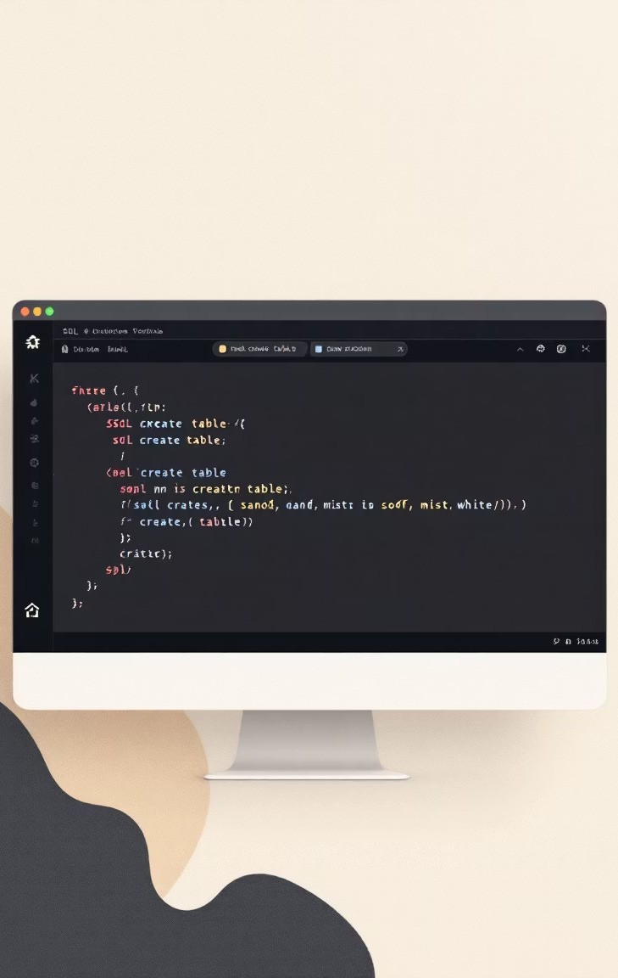

### DATA DEFINITION LANGUAGE (DDL): BUILDING THE FOUNDATION

###### CREATE TABLE



This fundamental DDL command is used to define and create the structure of our database tables, specifying column names, data types, and constraints.

###### ALTER TABLE

Used to modify the structure of an existing table, such as adding, deleting, or modifying columns, or adding/dropping constraints.

###### DROP TABLE

Used to delete an existing table from the database, including all its data and structure.

DDL commands are critical in the initial setup phase, allowing us to precisely define the schema and ensure that our database is structured to meet the specific needs of a film production company.

### DATA INTEGRITY: PRIMARY AND FOREIGN KEYS



#### PRIMARY KEY

A primary key is a unique identifier for each record in a table. It ensures that every row can be uniquely identified and serves as the backbone for establishing relationships.

"A primary key acts like a unique fingerprint for each entry, guaranteeing no two records are identical."

#### FOREIGN KEY

A foreign key is a column or a set of columns in one table that refers to the primary key in another table. It establishes and enforces a link between the data in two tables, ensuring referential integrity.

"Foreign keys are the bridges connecting tables, maintaining the consistency of our data across the entire database."

These keys are fundamental to maintaining the reliability and consistency of our film production database, preventing erroneous or orphaned records.



### CONSTRAINT IMPLEMENTATION: ENSURING DATA CONSISTENCY

Implementing constraints like Foreign Keys is crucial for maintaining data integrity and relationships between tables. This prevents inconsistent data from being stored in our database.

ALTER TABLE AudienceSurveys

ADD FOREIGN KEY (FilmID) REFERENCES Films(FilmID) ON DELETE CASCADE;

#### ON DELETE CASCADE

When a record in the parent table (e.g., Films) is deleted, all corresponding records in the child table (e.g., AudienceSurveys) are automatically deleted.

This ensures that there are no "orphan" survey records pointing to non-existent films.

It's a powerful mechanism for maintaining referential integrity, though it must be used with caution to prevent unintended data loss.



## MASTERING SQL FOR FILM DATA ANALYSIS

Embark on a cinematic journey into data with SQL! This presentation will guide you through essential SQL commands, enabling you to retrieve, analyse, and interpret film and entertainment data like a pro. Get ready to unlock the stories hidden within your databases.



### BASIC DATA RETRIEVAL: YOUR FIRST SQL STEPS

Our SQL adventure begins with the fundamental statement. This command is

SELECT

your gateway to accessing data stored in tables. Let's learn how to pull everything and then refine our view.

THE UNIVERSAL SELECTOR: SELECT *

**To retrieve all columns from a table, use the asterisk (*). For example,** SELECT * FROM Films; **fetches every piece of information about each film.**

TARGETED RETRIEVAL: SPECIFYING COLUMNS

**For specific data, list the column names:** SELECT Title, ReleaseDate FROM Films; **This keeps your results focused and manageable.**



### FILTERING DATA: THE POWER OF

WHERE

Raw data can be overwhelming. The clause is your precision tool, allowing you

WHERE

to filter rows based on specific conditions, ensuring you only see the data that matters.

CONDITIONAL SELECTION

**Use** WHERE **with operators like =, <>, >, <, >=, <=. For instance,** SELECT * FROM Films WHERE Genre = 'Action'; **retrieves all action films.**

COMBINING CONDITIONS

**Combine multiple conditions with** AND**,** OR**, and** NOT **for complex filters. SELECT Title FROM Films WHERE ReleaseYear > 2020 AND Rating > 7.5;**

### ORDERING AND LIMITING RESULTS

LIMIT

Once you've retrieved your data, you'll often want to see it in a particular order or manage the number of results. this.

ORDER BY

###### SORTING YOUR VIEW WITH

ORDER BY

Sort your results in ascending (ASC) or descending (DESC) order based on one or more columns.

SELECT Title, ReleaseDate FROM Films

**and**

are perfect for

shows the newest films first.

ORDER BY ReleaseDate DESC;

###### PAGING THROUGH DATA WITH

LIMIT

Control the number of rows returned using LIMIT. This is incredibly useful for pagination.

SELECT * FROM Films ORDER BY Rating

gives you the top 10 highest-rated films.

DESC LIMIT 10;

### AGGREGATE FUNCTIONS: SUMMARISING YOUR DATA

Aggregate functions perform calculations on a set of rows and return a single summary value. They are indispensable for gaining high-level insights from your film data.



COUNT()



SUM()

Tally the number of rows or non-NULL values.

SELECT

tells you how many films are in your

COUNT(*) FROM Films;

database.

Calculate the total sum of a numeric column.

reveals the total budget across

SELECT

SUM(Budget) FROM Films;

all films.

AVG()

Determine the average value of a numeric column.

SELECT

finds the average rating of all

AVG(Rating) FROM Films;

films.

&

Find the highest or lowest value in a column. SELECT

MAX()

MIN()

MAX(ReleaseDate), MIN(ReleaseDate) FROM Films;

identifies the oldest and newest films.



### GROUPING DATA WITH

GROUP BY

allows you to organise rows that have the same values into summary rows. This is perfect for categorising your film data and applying aggregate functions to each category.

GROUP BY

###### CATEGORISING YOUR FILMS

**Group films by attributes like** Genre**,** ProductionCompany**, or aggregated results for each distinct category.**

to see

Director

###### EXAMPLE: FILMS PER PRODUCTION COMPANY

To see which production companies are most prolific:

SELECT Genre, COUNT(*) AS NumberOfFilms FROM Films GROUP BY

This query counts films per genre.

Genre;

This provides a clear overview of output from each studio.

SELECT

ProductionCompany,

COUNT(FilmID) AS TotalFilmsProduced FROM

Films

GROUP BY

ProductionCompany ORDER BY

TotalFilmsProduced DESC;

### FILTERING GROUPS WITH

HAVING

While

WHERE

filters individual rows,

filters groups after they've been

aggregated. It's the perfect companion for summary results.

HAVING

GROUP BY

###### WHY HAVING?

when you need to refine your

You can't use aggregate functions directly in a

clause.

steps

in to filter based on the results of those aggregates. Think of it as a clause for groups.

WHERE

HAVING

WHERE

###### EXAMPLE: HIGH-RATED GENRES

To find genres where the average rating is above 7.0: SELECT Genre,

AVG(Rating) FROM Films GROUP BY Genre HAVING AVG(Rating) >

7.0;

###### FILMS WITH SIGNIFICANT BUDGETS

Identify production companies whose average film budget exceeds a certain amount: SELECT ProductionCompany, AVG(Budget) FROM Films GROUP BY ProductionCompany HAVING AVG(Budget) > 50000000;

### JOINS: UNITING YOUR DATA WITH

INNER JOIN

Data in a database is often spread across multiple tables. common field, revealing richer insights.

INNER JOIN

###### THE CORE PRINCIPLE

returns only the rows that have matching values in both tables. If a film has no director listed, or a director has no films, they won't appear in the result.

INNER JOIN

is your primary tool for combining rows from two or more tables based on a

###### EXAMPLE: FILM TITLES AND DIRECTORS

To list film titles alongside their director's name:

SELECT

F.Title, D.DirectorName

FROM

Films AS F INNER JOIN

Directors AS D ON

F.DirectorID = D.DirectorID;

This query connects film records with director records using their shared ID.

is crucial for navigating relational databases and answering questions that span across different data entities.

INNER JOIN

### ADVANCED JOINS: AND RIGHT JOINS

LEFT

RIGHT JOIN

Sometimes you need to include data even when there isn't a perfect match. one side of the join.

LEFT JOIN

**and**

allow you to include unmatched rows from

###### LEFT JOIN (OR LEFT OUTER JOIN)



Returns all rows from the left table, and the matching rows from the right table. If there's no match on the right, NULLs are returned for the right table's columns.

###### RIGHT JOIN (OR RIGHT OUTER JOIN)

Returns all rows from the right table, and the matching rows from the left table. If there's no match on the left, NULLs are returned for the left table's columns.

Use Case: Listing all directors, even those without an assigned film yet, to check for new talent or incomplete data. SELECT D.DirectorName, F.Title FROM Directors AS D LEFT JOIN Films AS F ON D.DirectorID = F.DirectorID;

[](https://gamma.app/?utm_source=made-with-gamma)

### COMPLEX JOINS: SELF-JOIN AND MULTI-TABLE JOIN

SQL's joining capabilities extend to self-referencing data and combining multiple datasets, enabling powerful and intricate data analysis.

###### SELF-JOIN

Joining a table to itself. Useful for finding relationships within the same table, like finding crew members who worked on the same film or comparing records.

###### MULTI-TABLE JOIN



Connecting three or more tables to gather comprehensive data. For instance, linking Films, Directors, and Production Companies to get a complete picture of film projects.

###### EXAMPLE: FILM, DIRECTOR, & COMPANY

Combine data from Films, Directors, and ProductionCompanies tables to see which director worked for which company on a specific film.





## MASTERING SQL WINDOW FUNCTIONS: A COMPREHENSIVE GUIDE

Welcome to this in-depth guide on SQL Window Functions. This presentation is designed for data analysts and SQL learners who are familiar with basic SQL concepts and eager to elevate their data manipulation skills. We will explore how window functions empower you to perform powerful calculations over related sets of rows, unlocking deeper insights from your data.

## UNDERSTANDING WINDOW FUNCTIONS: THE CORE CONCEPT

###### CALCULATIONS ACROSS ROWS



Window functions allow you to perform calculations across a specific set of table rows that are somehow related to the current row.

###### CONTEXTUAL ANALYSIS

Unlike regular aggregate functions, window functions do not collapse rows. They return a value for each row, adding contextual richness to your query results.

###### KEY KEYWORDS

Mastering window functions involves understanding keywords like OVER(), PARTITION BY, and ORDER BY. These define the "window" or set of rows for your calculation.

## RANKING FUNCTIONS: SEQUENTIAL ORDERING WITH ROW_NUMBER()

The function is a fundamental ranking function. It assigns a unique,

ROW_NUMBER()

sequential integer to each row within its partition, based on the specified order.



PURPOSE OF ROW_NUMBER()

**To assign a distinct rank to each row, especially useful when you need a clear, non-overlapping sequence for every entry.**

Consider a scenario from Project Phase 3 where you need to assign a row number to data entries per region. This helps in identifying the first, second, or nth entry within each region.

For example, if you have sales data, can identify the first sale of the day for each salesperson.

ROW_NUMBER()

## ADVANCED RANKING: RANK() VS. DENSE_RANK()

RANK() FUNCTION

**The** RANK() **function assigns a rank to each row within its partition. If two or more rows have identical values in the ordering column, they receive the same rank, and the next rank(s) in the sequence are skipped.**

**Example: 1, 2, 2, 4**

DENSE_RANK() FUNCTION

**In contrast,** DENSE_RANK() **also assigns ranks to rows, giving identical values the same rank. However, it does not skip any ranks in the sequence. It provides a continuous series of ranks.**

**Example (Project Phase 3): 1, 2, 2, 3**

Imagine ranking

ResponseCount

RANK()

same response count, while ranking.

DENSE_RANK()

**per** Film**.**

would show gaps if films had the would provide a cleaner, sequential

## VALUE FUNCTIONS: NAVIGATING DATA WITH LAG() AND LEAD()

###### LAG()

The function allows you to access data from a preceding row in

LAG()

the same result set, enabling comparisons with previous values.

###### LEAD()

Conversely, the

function lets you access data from a succeeding

LEAD()

row, facilitating comparisons with subsequent values.

These functions are invaluable for time-series analysis, trend identification, and calculating differences between consecutive records without self-joins.

## LAG() IN ACTION: COMPARING PREVIOUS RATINGS

###### EXAMPLE CODE (PROJECT PHASE 3):

LAG(Rating, 1) OVER (PARTITION BY FilmID ORDER BY

SurveyDate)

This code snippet retrieves the Rating from the previous row within each partition, ordered by SurveyDate.

###### USE CASE:

FilmID

This is extremely useful for comparing the current survey rating of a film with its immediate previous rating. It helps in understanding rating fluctuations or identifying patterns in customer feedback over time for a particular film.

Imagine tracking customer satisfaction scores for a product; before.

LAG()

helps you see if the latest score is an improvement or decline from the one just

## LEAD() IN ACTION: ANTICIPATING FUTURE RATINGS

###### EXAMPLE CODE (PROJECT PHASE 3):

LEAD(Rating, 1) OVER (PARTITION BY FilmID ORDER BY

SurveyDate)

This function fetches the Rating from the next row within each partition, ordered by SurveyDate.

###### USE CASE:

FilmID

Using LEAD(), you can compare the current survey rating of a film with its next upcoming rating. This can be critical for predictive analysis or to identify potential future trends or changes in sentiment.

This function is particularly valuable for trend spotting, allowing analysts to anticipate upcoming changes or to prepare for future data points.

## AGGREGATE WINDOW FUNCTIONS: BEYOND SIMPLE AGGREGATES

AGGREGATES IN CONTEXT

**Window functions allow you to use standard aggregate functions like** SUM() **and** AVG() **over a defined**

**"window frame," providing context-**

**specific aggregations.**

CUMULATIVE CALCULATIONS

**A common application is calculating cumulative sums or running averages, which show how a value changes over a sequence of rows.**

EXAMPLE (PROJECT PHASE 4)

**Calculating cumulative responses per film illustrates this. You can see the total responses building up as new surveys come in for each film, providing a dynamic view of engagement.**

DISTRIBUTION FUNCTIONS: PERCENT_RANK() & NTILE()

Distribution functions provide insight into how individual values rank or fall within specific groups or segments of your data.

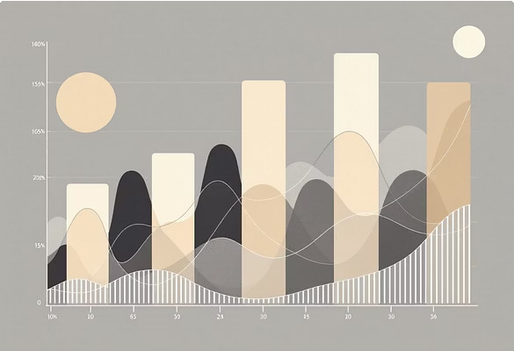

PERCENT_RANK()

**This function calculates the relative rank of a value within its window, expressed as a percentile. It's useful for understanding how a specific data point compares to the rest of the dataset.**

**Example (Project Phase 3): Determine the percent rank of ratings per film to see how well each rating performs relative to others for that film.**

NTILE()

NTILE() **divides the ordered data set into a specified number of approximately equal groups (e.g., quartiles, deciles). This is invaluable for segmentation and creating balanced groups for analysis.**

**Example (Project Phase 3): Assign a quartile to response counts to categorize films into groups based on their engagement levels.**

## WINDOW FRAMING: PRECISION IN CALCULATION WITH ROWS BETWEEN

Window framing is a powerful concept within window functions, allowing you to define a specific subset of the partition on which the calculation is performed. This provides granular control over the data included in your window operations.



CONCEPT: ROWS BETWEEN

ROWS BETWEEN **allows you to specify a starting and ending point for the window frame relative to the current row. This includes options like** UNBOUNDED PRECEDING**,** CURRENT ROW**, and** UNBOUNDED

FOLLOWING**.**

**Example (Project Phase 3): Using** LAST_VALUE(...) ROWS BETWEEN UNBOUNDED PRECEDING AND UNBOUNDED FOLLOWING**, you can retrieve**

the last value within the entire partition, regardless of the current row, highlighting the flexibility of window framing.



## ENHANCING SQL: VIEWS, CTES, AND ADVANCED FEATURES

This presentation delves into powerful SQL constructs that streamline data management, enhance security, and optimise performance for developers and data engineers.



PROJECT PHASE 2 EXAMPLE

# UNDERSTANDING SQL VIEWS

WHAT ARE VIEWS?

**Views are essentially virtual tables derived from the result-set of an SQL query. They do not store data themselves, but rather present data stored in other tables.**

PRACTICAL APPLICATION

**Consider a scenario where you need to frequently access survey data that meets specific criteria. A view can simplify this process.**

CREATE VIEW HighRatedSurveys AS SELECT *

FROM AudienceSurveys

WHERE Rating > 4;



## KEY BENEFITS OF UTILISING VIEWS



ENHANCED SECURITY

**Views provide a robust mechanism for restricting data access. You can expose only specific columns or rows to users, safeguarding sensitive information without granting direct table access.**

SIMPLIFIED QUERIES

**Complex queries involving multiple joins and intricate logic can be encapsulated within a view. This simplifies subsequent queries, allowing users to interact with a seemingly simpler data structure.**



PROJECT PHASE 2 EXAMPLE

# COMMON TABLE EXPRESSIONS (CTES)



SCOPED AVAILABILITY

**CTEs improve readability and maintainability of complex queries by breaking them down into logical, smaller, and more manageable building blocks.**

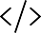

THE `WITH` KEYWORD

**CTEs are defined using the** WITH **keyword, allowing you to create temporary, named result sets that are available within the scope of a single SQL query.**



TEMPORARY RESULT SETS

**These result sets are temporary; they exist only for the duration of the query execution and are not stored permanently in the database.**

## CTE EXAMPLE: CALCULATING REGIONAL AVERAGES

CTEs are particularly useful for multi-step calculations or recursive queries.

This example demonstrates how to first calculate the

WITH RegionAvg AS (

SELECT Region, AVG(Rating) AS AverageRating

FROM AudienceSurveys GROUP BY Region

)

SELECT A.SurveyID, A.Region, A.Rating, R.AverageRating

FROM AudienceSurveys A

JOIN RegionAvg R ON A.Region = R.Region

WHERE A.Rating > R.AverageRating;

average rating per region and then use that average in a subsequent query to find surveys with ratings above their regional average.

PROJECT PHASE 4 EXAMPLE

# STORED PROCEDURES: PRE- COMPILED SQL

#### DEFINITION

Stored procedures are pre-compiled collections of SQL statements. They are stored in the database and can be executed multiple times.

#### PERFORMANCE BOOST

Since they are pre-compiled, stored procedures generally execute faster than individual SQL statements, reducing network traffic and improving application performance.

#### ENHANCED SECURITY

Stored procedures allow database administrators to grant users permissions to execute the procedure without granting direct access to the underlying tables, thus improving security.



## EXECUTING STORED PROCEDURES

Consider a scenario where survey ratings need to be updated frequently. A stored procedure can centralise this logic.

Once created, the procedure can be called with specific parameters, making the update process consistent and efficient.

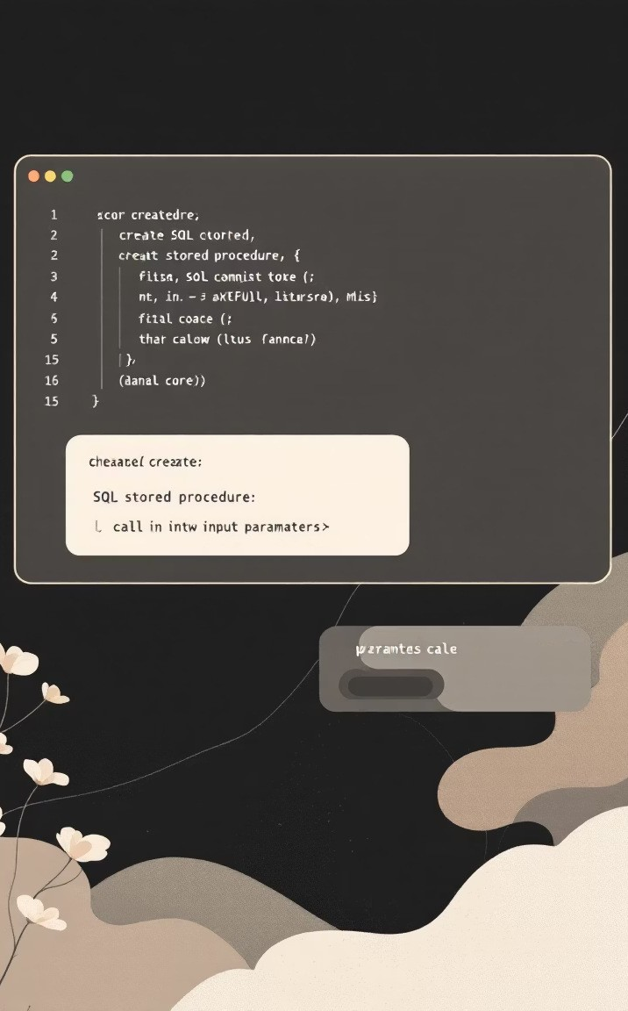

CREATE PROCEDURE

UpdateSurveyRating ( IN pID INT,

IN pRating INT

) BEGIN

UPDATE AudienceSurveys SET Rating = pRating WHERE SurveyID = pID;

END;

CALL UpdateSurveyRating(5, 10);

## USER-DEFINED FUNCTIONS (UDFS)

UDFs extend SQL's functionality, allowing you to encapsulate custom logic that can be reused across queries.

#### SCALAR UDFS

These functions return a single value, such as a calculated result based on input parameters. Perfect for custom calculations.

#### TABLE-VALUED UDFS

Table-valued functions return a table, which can then be used in the clause of a query, much like a regular table or view.

FROM

#### CUSTOM CALCULATIONS

UDFs are ideal for standardising complex calculations or business logic that needs to be applied consistently across your database queries.

PROJECT PHASE 4 EXAMPLE

# TRIGGERS: AUTOMATING DATABASE ACTIONS

Triggers are special types of stored procedures that execute automatically when a specific event occurs on a database table, such as an INSERT, operation.

UPDATE**, or**

DELETE

A common use case is to log changes, such as deleted surveys, into an audit table to maintain data integrity and traceability.

CREATE TRIGGER after_audiencesurveys_delete AFTER DELETE ON AudienceSurveys

FOR EACH ROW BEGIN

INSERT INTO SurveyAudit (SurveyID, Action, Timestamp) VALUES (OLD.SurveyID, 'DELETE', NOW());

END;

The keyword refers to the row that was just deleted, allowing its data to be captured before it's permanently removed.

OLD

## INDEXES: OPTIMISING DATA RETRIEVAL

Indexes are crucial for enhancing the speed of data retrieval in large databases, but they come with a trade-off.

#### FASTER READS

Indexes work by creating a data structure (like a B-tree) that allows the database to quickly locate rows without scanning the entire table. This significantly speeds up SELECT queries.

#### SLOWER WRITES

While indexes accelerate data retrieval, they can slow down data modification operations (INSERT, UPDATE, DELETE) because the index itself must also be updated.



## FILM PRODUCTION ANALYTICS: UNVEILING INSIGHTS WITH SQL

Welcome to our exploration of film production data analytics, powered by SQL. This presentation delves into how robust database design and advanced querying techniques can illuminate critical insights within the film industry. We will be

showcasing the project.

**Film_Production_Company**



### DEEP DIVE INTO ADVANCED DATA ANALYSIS: CROSS- JOINING FOR COMPREHENSIVE INSIGHTS

THE POWER OF CROSS-JOINS

**Cross-joining is a fundamental SQL technique for generating every possible combination between two tables. In film production, this means creating a comprehensive matrix, for example, linking every director to every studio.**

REAL-WORLD USE CASES

**Imagine analyzing potential director-studio pairings, or even director-genre combinations, to forecast success or identify untapped creative opportunities. This method allows for exhaustive analysis where every permutation matters.**

DATA CLEANING AND PREPARATION: REFINING OUR RAW DATA

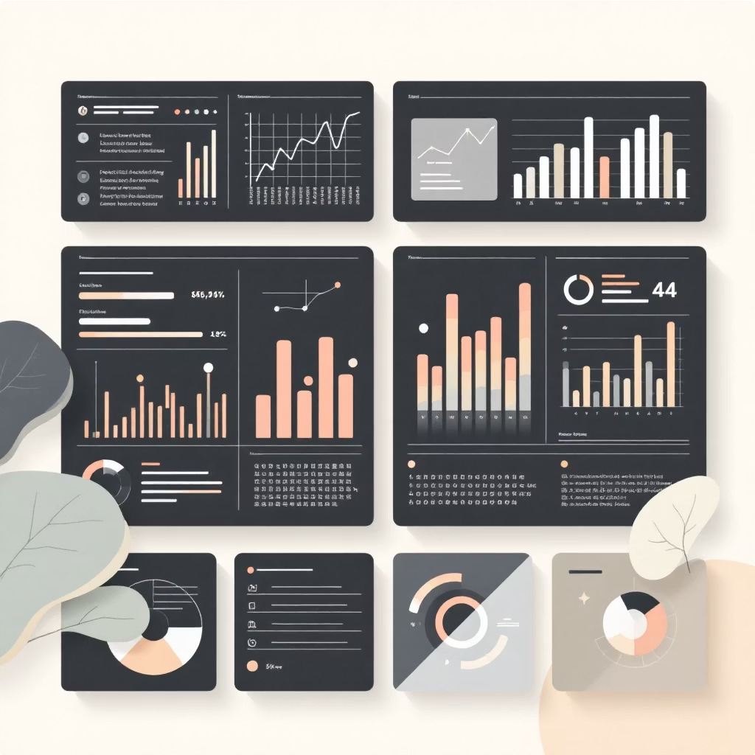Effective data analysis hinges on meticulously cleaned and prepared data. We employ cAsE statements extensively to categorise raw numeric data into meaningful, descriptive groups. This transformation is crucial for making data more interpretable and actionable.

For instance, a film's budget can be classified into 'High', 'Medium', or 'Low' categories. This simplification allows for easier segmentation and comparative analysis across different budget tiers, revealing trends that might be obscured by granular figures.

"Clean data is not just about correctness; it's about context and clarity."

### ANALYZING AUDIENCE FEEDBACK: DECIPHERING VIEWER PREFERENCES

Understanding audience preferences is paramount in the film industry. By joining the Films and AudienceSurveys tables, we can correlate specific film genres with their average ratings.

Our primary objective is to identify which film genres consistently receive the highest average ratings, providing valuable insights for future production decisions and marketing strategies. This direct feedback loop helps in tailoring content to viewer demands.

### TIME-SERIES ANALYSIS: UNCOVERING PRODUCTION TRENDS

**$120.00**



**$80.00**

**$40.00**

**$0.00**

**2018 2019 2020 2021 2022 2023**

Analyzing ReleaseDate against Budget over time helps us pinpoint peak production years and budget allocation trends. The above chart illustrates the average film budget across different years, showing a general upward trend with some fluctuations.

Identifying these patterns allows us to understand market dynamics and anticipate future investment cycles in film production.

### COMPLEX QUERY EXAMPLE 1: AWARD-WINNING FILMS POST-2022

###### MULTI-JOIN STRATEGY

We construct a query involving multiple joins to connect Films with Awards data. This ensures we capture films that have indeed received recognition.

###### DATE FILTERING

A critical component is filtering for films released specifically after 2022. This allows us to focus on recent successes and emerging trends within the award circuit.



This complex query helps us pinpoint recent, critically acclaimed productions, offering insights into contemporary film excellence.



### COMPLEX QUERY EXAMPLE 2: RANKING CREW EXPERIENCE

1

DEPARTMENTAL PARTITIONING

**We utilise the PARTITION BY (Department) clause to segment our crew data, allowing for independent ranking within each specific department.**

2

EXPERIENCE RANKING

**The RANK() function, applied to (ExperienceYears), then assigns a rank to each crew member based on their experience within their respective department.**

This advanced query helps identify key talent within each department, facilitating resource allocation and project planning based on experience levels.

### PROJECT CHALLENGES AND SOLUTIONS

###### DATA CONSISTENCY

Ensuring data integrity across all tables was a primary concern.

###### FOREIGN KEYS

Implemented Foreign Keys and integrity constraints to maintain relational consistency.

###### COMPLEX REPORTING

Addressing sophisticated analytical reporting needs required advanced SQL.

###### WINDOW FUNCTIONS & CTES

Utilised Window Functions and Common Table Expressions (CTEs) for intricate analyses.

Each challenge presented an opportunity to apply robust SQL solutions, reinforcing the project's foundation.

### KEY LEARNING OUTCOMES & FUTURE ENHANCEMENTS

#### LEARNING OUTCOMES

 Mastery of database design and normalisation principles.  Proficiency in DDL, DML, and DQL operations.

 Expertise in analytical SQL, particularly Window Functions.

 Ability to create reusable database objects (Procedures, Views, Triggers).

#### NEXT STEPS

 Implementing user management tables for enhanced security and access control.

 Seamlessly integrating the SQL backend with a Java Spring Boot application for a full-stack solution.

 Optimising slow queries through extensive Index tuning for improved performance.





## THANK YOU

### PROJECT: FILM_PRODUCTION_COMPANY

#### PRESENTER: TANMAYI PATIL

SPECIAL THANKS TO OUR MONITOR: SHALINI VERMA